In CSS, a CSS variable is any “property” whose name begins with two dashes.

.block { color: #8cacea;--color: blue}

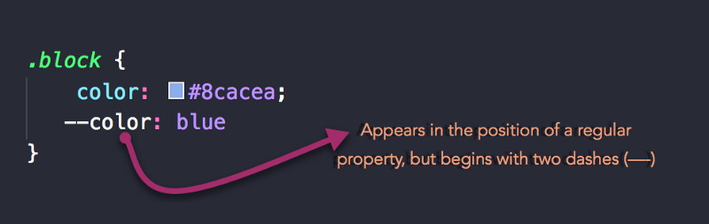

**Scoping CSS Variables**

There’s one more thing to point your attention to.

Remember that in JavaScript, variables have a scope. They may either have a global or local scope.

The same may be said of CSS variables.

Consider the example below:

:root { --main-color: red}

The :root selector allows you to target the highest-level element in the DOM, or document tree.

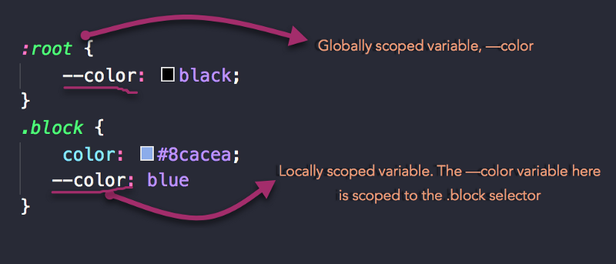

Define the variable

:root { --primary-color: red}

Remember, a CSS variable is any “property” whose name begins with two dashes e.g --color

### Using CSS Variables

Once a variable has been defined and assigned a value, you can go ahead and use it within a property value.

There’s a bit of a gotcha though.

If you’re coming from the world of preprocessors, you must be used to using a variable by just referencing its name. For example:

$font-size: 20px.test { font-size: $font-size}

With native CSS variables, things are a little different. You reference a variable by using the var() function.

With the example above, using CSS Variables will yield this:

:root { --font-size: 20px}.test { font-size: var(--font-size)}

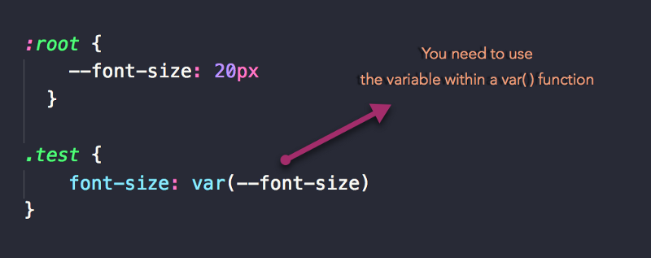

**GOTCHAS:**

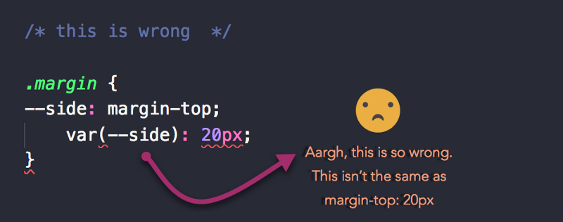

If you must do math, then use the calc() function like so:

.margin {--space: calc(20px * 2);font-size: var(--space); /*equals 40px*/}

#### 1. Custom properties are ordinary properties, so they can be declared on any element.

Declare them on a paragraph element, section, aside, root, or even pseudo elements. They’ll work as expected.

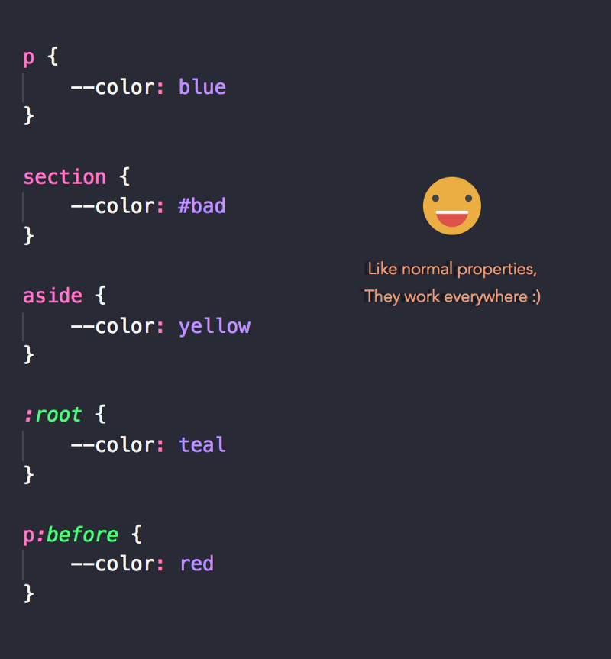

#### 2. CSS variables are resolved with the normal inheritance and cascade rules

Consider the block of code below:

div { --color: red;}div.test { color: var(--color)}div.ew { color: var(--color)}

As with normal variables, the --color value will be inherited by the divs.

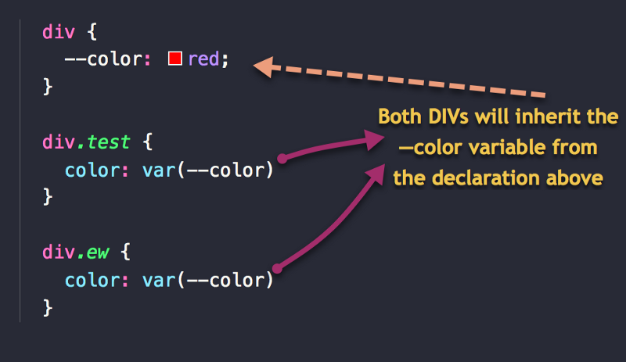

#### 3. CSS variables can be made conditional with @media and other conditional rules

As with other properties, you can change the value of a CSS variable within a @media block or other conditional rules.

For example, the following code changes the value of the variable, gutter on larger devices.

:root { --gutter: 10px }@media screen and (min-width: 768px) { --gutter: 30px}

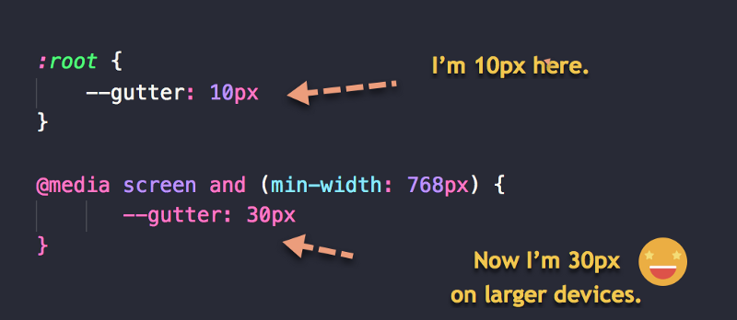

#### 4. CSS variables can be used in HTML’s style attribute.

You can choose to set the value of your variables inline, and they’ll still work as expected.

<!--HTML--><html style="--color: red"><!--CSS-->;body { color: var(--color)}

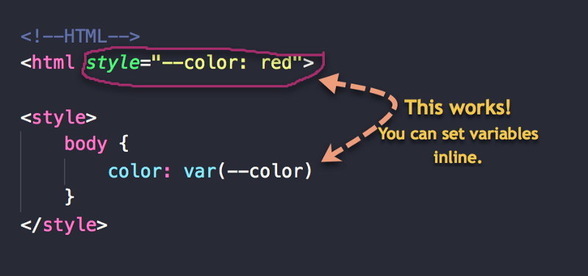

Set variables inline

**CSS variables are case-sensitive. Be careful with this one. I save myself the stress and**

**CHALLENGE:**

|  |  |
| --- | --- |
| <;p>What's my color?</p>  <div>and me?</div>  <div id='alert'> What's my color too?  <p>color?</p>  </div> | /*define the variables*/  :root { --color: blue; }  div { --color: green; }  #alert { --color: red; }  /*use the variable */*  { color: var(--color); } |
| **<p> Blue**  **<div> Green**  **<div id='alert'> Red** | The ID has a direct variable scoping. As such, the value within the definition will override the others. The selector #alert is more specific.  Finally, the p within the #alert will be… red |
|  |  |

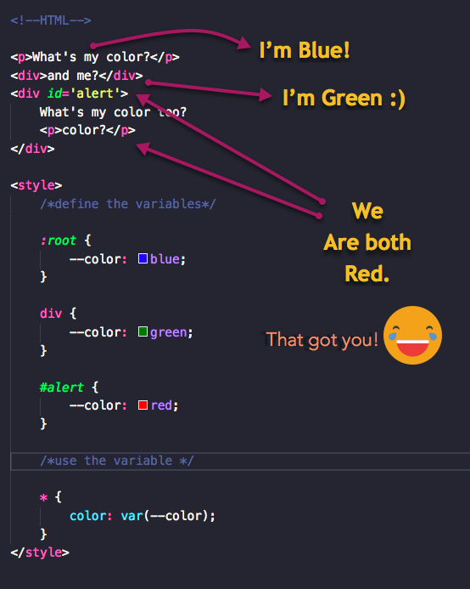

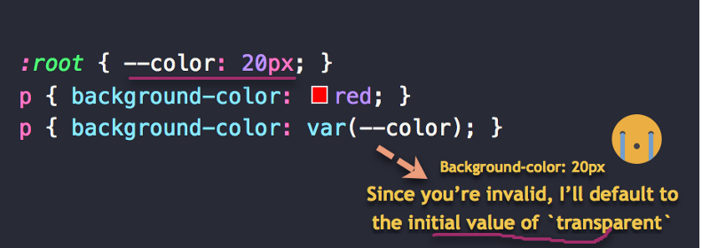

**Be Careful While Building Single Tokens**

When you set the value of a property as indicated below, the 20px is interpreted as a single token.

font-size: 20px

A simple way to put that is, the value 20px is seen as a single ‘entity.’

You need to be careful when building single tokens with CSS variables.

For example, consider the following block of code:

:root { --size: 20}div { font-size: var(--size)px /*WRONG*/}

You may have expected the value of font-size to yield 20px, but that is wrong.

The browser interprets this as 20 px

Note the space after the 20

Thus, if you must create single tokens, have a variable represent the entire token. For example, --size: 20px, or use the calc function e.g calc(var(--size) * 1px) where --size is equal to 20

Don’t worry if you don’t get this yet. I’ll explain it in more detail in a coming example.

**Examples:**

In this case, the properties that differ are the background-color and border-color of the variant.

So, how would you do this?

Here’s the typical solution.

Create a base class, say .btn and add the variant classes. Here’s an example markup:

<button class="btn">Hello</button&gt;<button class="btn red">Hello</button>

.btn would contain the base styles on the button. For example:

.btn { padding: 2rem 4rem; border: 2px solid black; background: transparent; font-size: 0.6em; border-radius: 2px;}

/*on hover */.btn:hover { cursor: pointer; background: black; color: white;}

So, where does the variant come in?

Here:

/* variations */.btn.red { border-color: red}.btn.red:hover { background: red}

You see how we are duplicating code here and there? This is good, but we could make it better with CSS variables.

What’s the first step?

Substitute the varying colors with CSS variables, and don’t forget to add default values for the variables!

.btn { padding: 2rem 4rem; border: 2px solid var(--color, black); background: transparent; font-size: 0.6em; border-radius: 2px; }

/*on hover*/ .btn:hover { cursor: pointer; background: var(--color, black); color: white; }

When you do this: background: **var(--color, black)** you’re saying, set the background to the value of the variable --color . However, if the variable doesn't exist, use the default value of **black**

This is how you set default variable values. Just like you do in JavaScript or any other programming language.

Here’s the good part.

With the variants, you just supply the new value of the CSS variable as under:

.btn.red { --color: red }

That’s all. Now when the .red class is used, the browser notes the different --color variable value, and immediately updates the appearance of the button.

This is really good if you spend a lot of time building reusable components.

Here’s a side by side comparison:

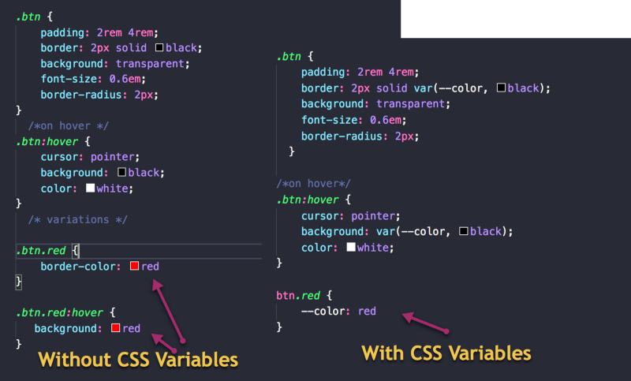Without CSS Variables VS with CSS Variables

Oh, and if you had more variants, you just saved yourself a lot of extra typing.

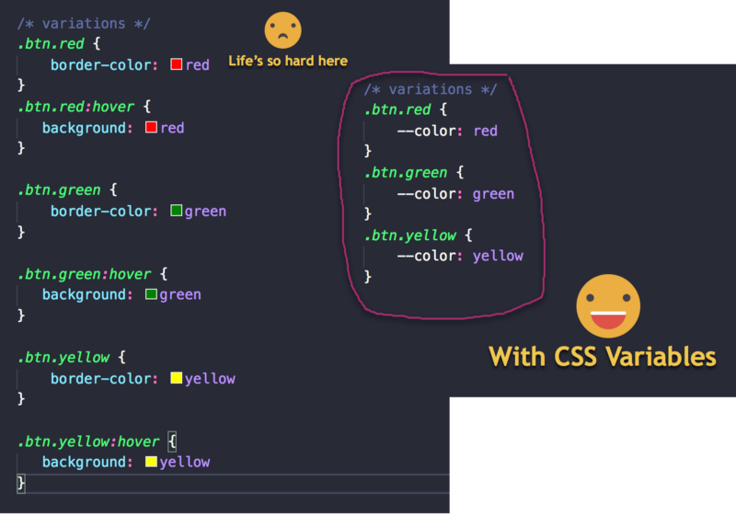See the difference??

**Project 2: Themed Sites with CSS Variables**

I’m sure you’ve come across them before. Themed sites give the user the feel of customization. Like they are in control.

Below is the basic example we’ll build.



So, how easy do the CSS variables make this?

We’ll have a look.

Just before that, I wanted to mention that this example is quite important. With this example, I’ll introduce the concept of updating CSS variables with JavaScript.

It is fun!

You’ll love it.

**What we really want to do.**

The beauty of CSS variables is their reactive nature . As soon as they are updated, whatever property has the value of the CSS variable gets updated as well.

Conceptually, here’s an image that explains the process with regards to the example at hand.

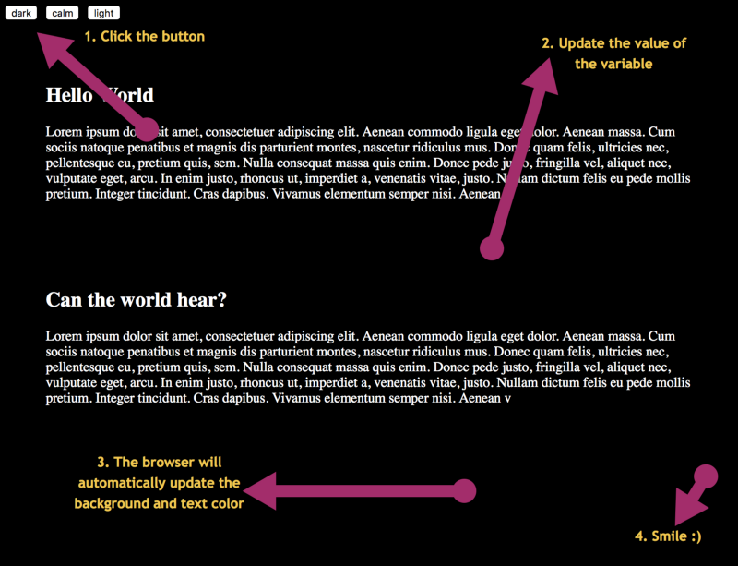The process

So, we need some JavaScript for the click listener.

For this simple example, the background and color of the text of the entire page is based off of CSS variables.

When you click any of the buttons above, they set the CSS variable to some other color. As a result of that, the background of the page is updated.

Hey, that’s all there is to it.

Uh, one more thing.

When I say the CSS variable is set to some other value, how’s that done?

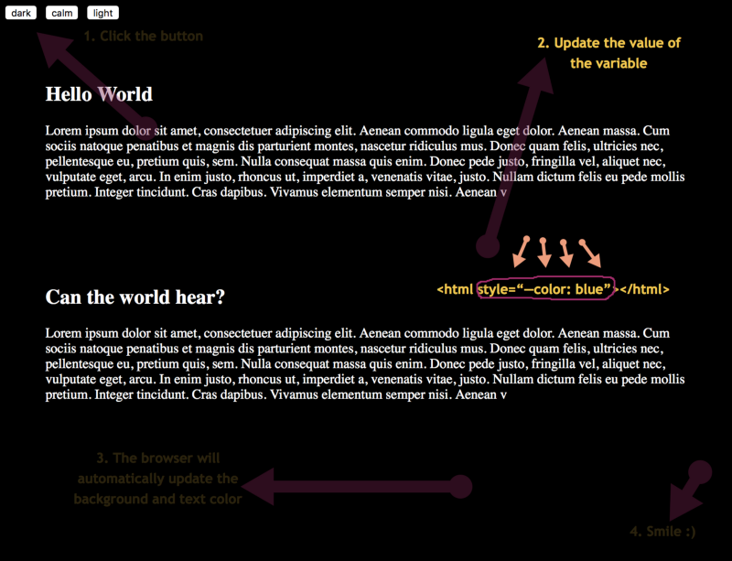Set the variable inline

CSS variables will take effect even if they are set inline. With JavaScript, we get a hold of the root document, and we set the new value for the CSS variable inline.

Got that?

That’s a lot of talking — let’s do the real thing.

**The initial markup**

The initial markup needed is this:

<div class="theme"> <button value="dark">dark</button> <button value="calm">calm</button> <button value="light">light</button></div><article>...</article>

The markup consists of three buttons within a .theme parent element. To keep things short I have truncated the content within the article element. Within this article element is the content of the page.

**Styling the Page**

The success of this project begins with the styling of the page. The trick is simple.

Instead of just setting the background-color and color of the page in stone, we will set them based on variables.

Here’s what I mean.

body { background-color: var(--bg, white); color: var(--bg-text, black)}

The reason for this is kind of obvious. Whenever a button is clicked, we will change the value of both variables within the document.

Upon this change, the overall style of the page will be updated. Easy-peasy.

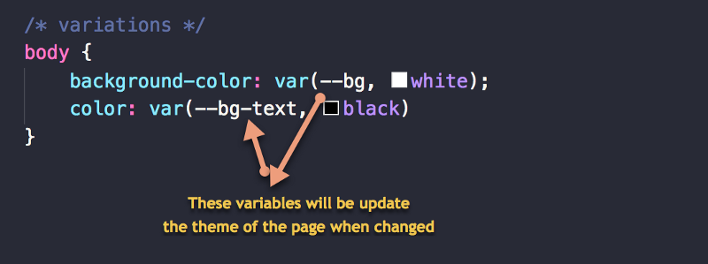

So, let’s go ahead and handle the update from JavaScript.

**Getting into the JavaScript**

I’ll go ahead and spit out all the JavaScript needed for this project.

const root = document.documentElement const themeBtns = document.querySelectorAll('.theme > button')themeBtns.forEach((btn) => { btn.addEventListener('click', handleThemeUpdate)})function handleThemeUpdate(e) { switch(e.target.value) { case 'dark': root.style.setProperty('--bg', 'black') root.style.setProperty('--bg-text', 'white') break case 'calm': root.style.setProperty('--bg', '#B3E5FC') root.style.setProperty('--bg-text', '#37474F') break case 'light': root.style.setProperty('--bg', 'white') root.style.setProperty('--bg-text', 'black') break }}

Don’t let that scare you. It’s a lot easier than you probably think.

First off, keep a reference to the root element, const root = document.documentElement

The root element here is the HTML element. You’ll see why this is important in a bit. If you’re curious, it is needed to set the new values of the CSS variables.

Also, keep a reference to the buttons too, const themeBtns = document.querySelectorAll('.theme > button')

querySelectorAll yields an array-like data structure we can loop over. Iterate over each of the buttons and add an event listener to them, upon click.

Here’s how:

themeBtns.forEach((btn) => { btn.addEventListener('click', handleThemeUpdate)})

Where’s the handleThemeUpdate function? I’ll discuss that next.

Every button being clicked will have the handleThemeUpdate as its callback function. It becomes important to note what button was clicked and then perform the right operation.

In the light of that, a switch operator is used, and some operations are carried out based on the value of the button being clicked.

Go ahead and take a second look at the block of JavaScript code. You’ll understand it a lot better now.

**Project 3: Building the CSS Variable Booth ?**

In case you missed it, here’s what we’ll build:



Remember that the color of the boxes are dynamically updated, and that the box container is rotated in 3d space as the range input is changed.



You can go ahead and play with it on [Codepen](https://codepen.io/ohansemmanuel/full/EoBLgd/).

This is a superb example of updating CSS variables with JavaScript and the reactivity that comes with it.

Let’s see how to build this.

**The Markup**

Here are the needed components.

1. A range input
2. A container to hold the instructions
3. A section to hold a list of other boxes, each containing input fields

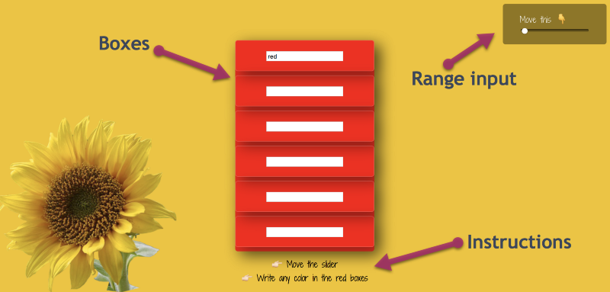

The markup turns out simple.

Here it is:

<main class="booth"> <aside class="slider"> <label>Move this ? </label> <input class="booth-slider" type="range" min="-50" max="50" value="-50" step="5"/> </aside> <section class="color-boxes"> <div class="color-box" id="1"><input value="red"/></div> <div class="color-box" id="2"><input/></div> <div class="color-box" id="3"><input/></div> <div class="color-box" id="4"><input/&gt;</div&gt; <div class="color-box" id="5"><input/></div> <div class="color-box" id="6">;<input/>&lt;/div> </section> <footer class="instructions"> ?? Move the slider<br/> ?? Write any color in the red boxes </footer></main>

Here are a few things to point your attention to.

1. The range input represents values from -50 to 50 with a step value of 5 Also, the value of the range input is the minimum value, -50
2. If you aren’t sure how the range input works, check it out on [w3schools](https://www.w3schools.com/jsref/dom_obj_range.asp)
3. Note how the section with class .color-boxes contains other .color-box containers. Within these containers exist input fields.
4. It is perhaps worth mentioning that the first input has a default value of red.

Having understood the structure of the document, go ahead and style it like so:

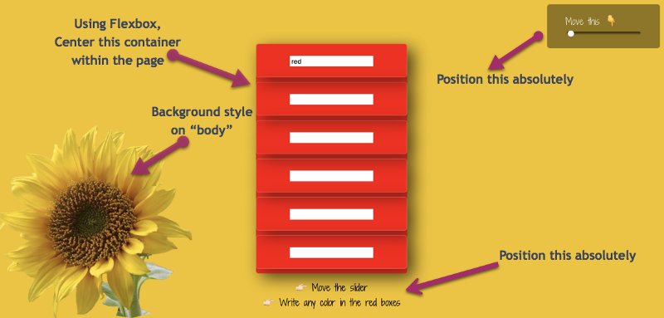

1. Take the .slider and .instructions containers out of the document flow. Position them absolutely.
2. Give the body element a sunrise background color and garnish the background with a flower in the bottom left corner
3. Position the color-boxes container in the center
4. Style the color-boxes container

Let’s knock these off.

The following will fix the first task.

/* Slider */.slider,.instructions { position: absolute; background: rgba(0,0,0,0.4); padding: 1rem 2rem; border-radius: 5px}.slider { right: 10px; top: 10px;}.slider > * { display: block;}/* Instructions */.instructions { text-align: center; bottom: 0; background: initial; color: black;}

The code snippet isn’t as complex as you think. I hope you can read through and understand it. If not, drop a comment or tweet.

Styling the body is a little more involved. Hopefully, you understand CSS well.

Since we aspire to style the element with a background color and a background image, it’s perhaps the best bet to use the background shorthand property to set multiple backgrounds.

Here it is:

body { margin: 0; color: rgba(255,255,255,0.9); background: url('http://bit.ly/2FiPrRA') 0 100%/340px no-repeat, var(--primary-color); font-family: 'Shadows Into Light Two', cursive;}

The url bit is the link to the sunrise flower.

The next set of properties 0 100% represent the background position of the image.

Here’s an illustration of how CSS background positioning works:

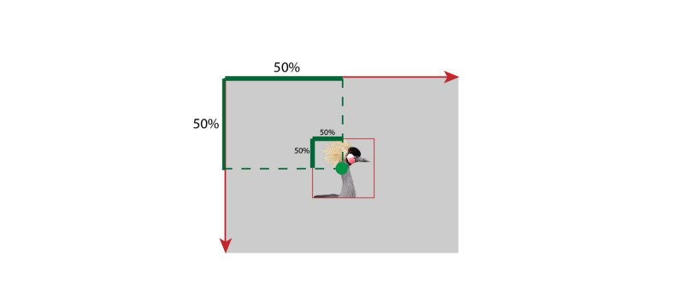From: [the advanced guide to CSS](http://bit.ly/learn_css)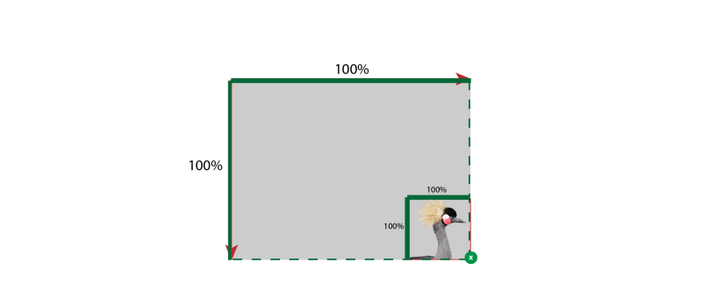From: [the advanced guide to CSS](http://bit.ly/learn_css)

The other bit after the forward slash represents the background-size This has been set to 340px If you made this smaller, the image would be smaller too.

no-repeat, you might figure out what that does. It prevents the background from repeating itself.

Finally, anything that comes after the comma is a second background declaration. This time we’ve only set the background-color to var(primary-color)

Oops, that’s a variable.

The implication of this is that you have to define the variable. Here’s how:

:root { --primary-color: rgba(241,196,15 ,1)}

The primary color there is the sunrise yellow color. No big deal. We’ll set some more variables in there soon.

Now, let’s center the color-boxes

main.booth { min-height: 100vh; display: flex; justify-content: center; align-items: center;}

The main container acts as a flex container and rightly positions the direct child in the center of the page. This happens to be our beloved color-box container

Let’s make the color-boxes container and its children elements pretty.

First, the child elements:

.color-box { padding: 1rem 3.5rem; margin-bottom: 0.5rem; border: 1px solid rgba(255,255,255,0.2); border-radius: 0.3rem; box-shadow: 10px 10px 30px rgba(0,0,0,0.4); }

That will do it. There’s a beautiful shadow added too. That’ll get us some cool effects.

That is not all. Let’s style the overall container-boxes container:

/* Color Boxes */.color-boxes { background: var(--secondary-color); box-shadow: 10px 10px 30px rgba(0,0,0,0.4); border-radius: 0.3rem; transform: perspective(500px) rotateY( calc(var(--slider) * 1deg)); transition: transform 0.3s}

Oh my!

There’s a lot in there.

Let me break it down.

Here’s the simple bit:

.color-boxes { background: var(--secondary-color); box-shadow: 10px 10px 30px rgba(0,0,0,0.4); border-radius: 0.3rem;}

You know what that does, huh?

There’s a new variable in there. That should be taken of by adding it to the root selector.

:root { --primary-color: rgba(241,196,15 ,1); --secondary-color: red;}

The secondary color is red. This will give the container a red background.

Now to the part that probably confused you:

/* Color Boxes */.color-boxes { transform: perspective(500px) rotateY( calc(var(--slider) * 1deg)); transition: transform 0.3s}

For a moment, we could simplify the value of the transform property above.

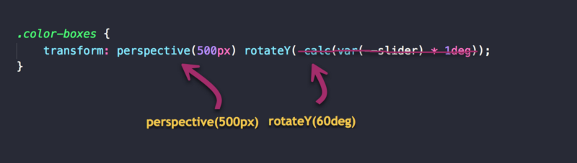

For example:

transform: perspective(500px) rotateY( 30deg);

The transform shorthand applies two different functions. One, the perspective, and the other, the rotation along the Y axis.

Hmmm, so what’s the deal with the perspective and rotateY functions?

The perspective() function is applied to an element that is being transformed in 3D space. It activates the three dimensional space and gives the element depth along the z-axis.

You can read more about the perspective function on [codrops](https://tympanus.net/codrops/css_reference/transform/#section_perspective).

The rotateY function, what’s the deal with that?

Upon activation the 3d space, the element has the planes x, y, z. The rotateY function rotates the element along the Y plane.

The following diagram from [codrops](https://tympanus.net/codrops/css_reference/transform/#section_rotate3d) is really helpful for visualizing this.

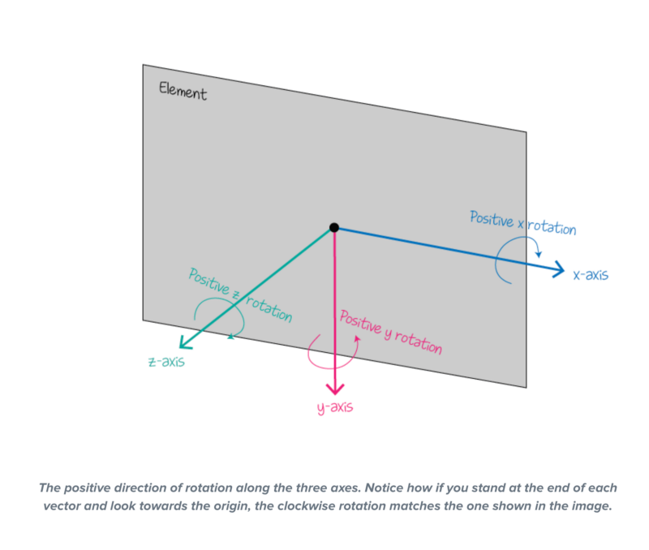[Codrops](https://tympanus.net/codrops/css_reference/transform/#section_rotate3d)

I hope that blew off some of the steam.

Back to where we started.



When you move the slider, do you know what function affects the rotation of the .container-box?

It’s the rotateY function being invoked. The box is rotated along the Y axis.

Since the value passed into the rotateY function will be updated via JavaScript, the value is represented with a variable.

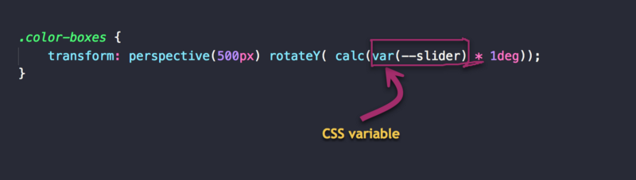

So, why multiply by the variable by 1deg?

As a general rule of thumb, and for explicit freedom, it is advised that when building single tokens, you store values in your variables without units.

You can convert them to any unit you want by doing a multiplication via the calc function.

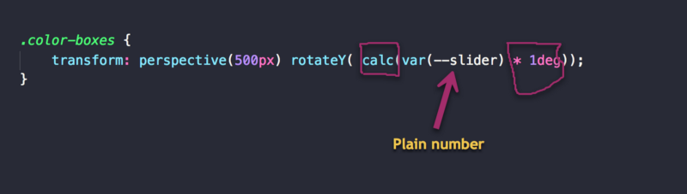

This allows you to do ‘whatever’ you want with these values when you have them. Want to convert to deg or as a ratio of the user’s viewport vw , you can whatever you want.

In this case, we are converting the number to have a degree by multiplying the “number” value by 1deg

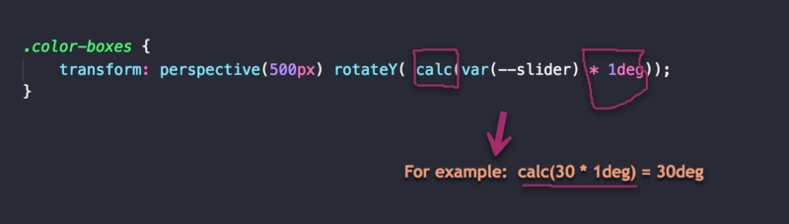

Since CSS doesn’t understand math, you have to pass this arithmetic into the calc function to be properly evaluated by CSS.

Once that is done, we’re good to go. The value of this variable can be updated in JavaScript as much as we like.

Now, there’s just one bit of CSS remaining.

Here it is:

/* Handle colors for each color box */.color-box:nth-child(1) { background: var(--bg-1)}.color-box:nth-child(2) { background: var(--bg-2)}.color-box:nth-child(3) { background: var(--bg-3)}.color-box:nth-child(4) { background: var(--bg-4)}.color-box:nth-child(5) { background: var(--bg-5)}.color-box:nth-child(6) { background: var(--bg-6)}

So, what’s this voodoo?

First off, the nth-child selector selects each of the child boxes.

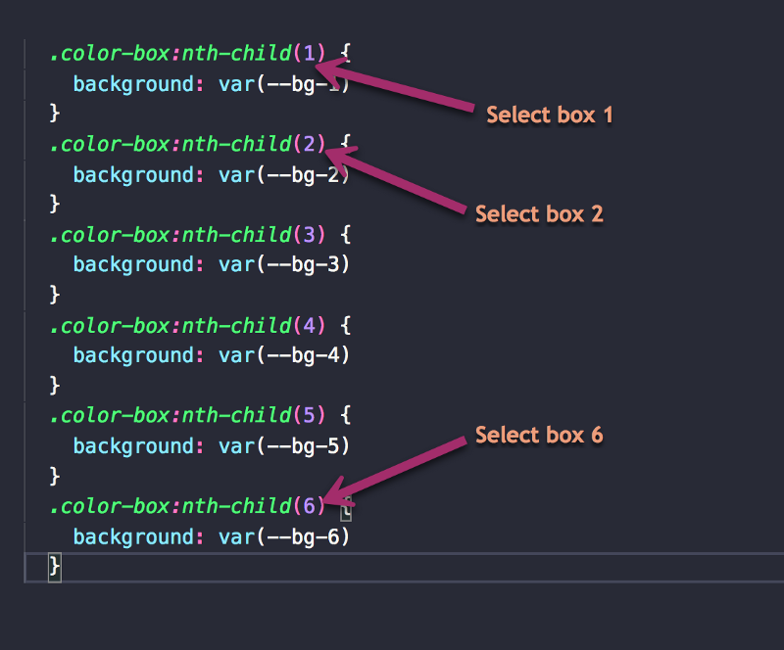

There’s a bit of foresight needed here. We know we will be updating the background color of each box. We also know that this background color has to be represented by a variable so it is accessible via JavaScript. Right?

We could go ahead and do this:

.color-box:nth-child(1) { background: var(--bg-1)}

Easy.

There’s one problem though. If this variable isn’t present, what happens?

We need a fallback.

This works:

.color-box:nth-child(1) { background: var(--bg-1, red)}

In this particular case, I have chosen NOT to provide any fallbacks.

If a variable used within a property value is invalid, the property will take on its initial value.

Consequently, when --bg-1 is invalid or NOT available, the background will default to its initial value of transparent.

Initial values refer to the values of a property when they aren’t explicitly set. For example, if you don’t set the background-color of an element, it will default to transparent

Initial values are kind of default property values.

**Let’s write some JavaScript**

There’s very little we need to do on the JavaScript side of things.

First let’s handle the slider.

We just need 5 lines for that!

const root = document.documentElementconst range = document.querySelector('.booth-slider')//as slider range's value changes, do something range.addEventListener('input', handleSlider)function handleSlider (e) { let value = e.target.value root.style.setProperty('--slider', value)}

That was easy, huh?

Let me explain just in case I lost you.

First off, keep a reference to the slider element, const range = document.querySelector('.booth-slider')

Set up an event listener for when the value of the range input changes, range.addEventListener('input', handleSlider)

Write the callback, handleSlider

function handleSlider (e) { let value = e.target.value root.style.setProperty('--slider', value)}

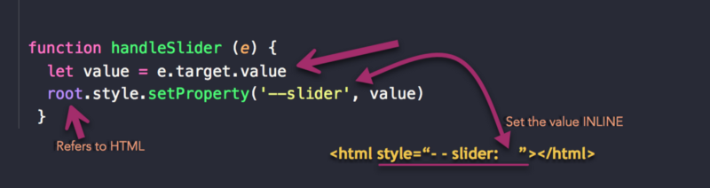

root.style.setProperty('--slider', value) says, get the root element (HTML) , grab its style, and set a property on it.

**Handling the color changes**

This is just as easy as handling the slider value change.

Here’s how:

const inputs = document.querySelectorAll('.color-box > input')

//as the value in the input changes, do something.inputs.forEach(input => { input.addEventListener('input', handleInputChange)})function handleInputChange (e) { let value = e.target.value let inputId = e.target.parentNode.id let inputBg = `--bg-${inputId}` root.style.setProperty(inputBg, value)}

Keep a reference to all the text inputs, const inputs = document.querySelectorAll('.color-box > input')

Set up an event listener on all the inputs:

inputs.forEach(input => { input.addEventListener('input', handleInputChange)})

Write the handleInputChange function:

function handleInputChange (e) { let value = e.target.value let inputId = e.target.parentNode.id let inputBg = `--bg-${inputId}` root.style.setProperty(inputBg, value)}

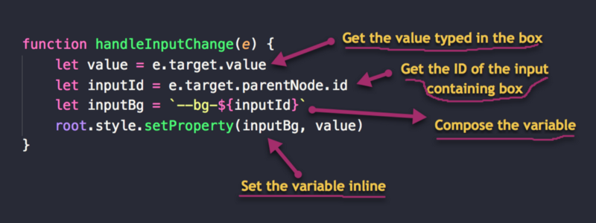

Phew…

That’s it!

Project’s done.

**How did I miss this?**

I had completed and edited the initial draft of this article when I noticed I didn’t mention browser support anywhere. So, let me fix my mess.

Browser support for CSS variables (aka custom properties) isn’t bad at all. It’s pretty good, with decent support across all modern browsers (over 87% at the time of this writing).

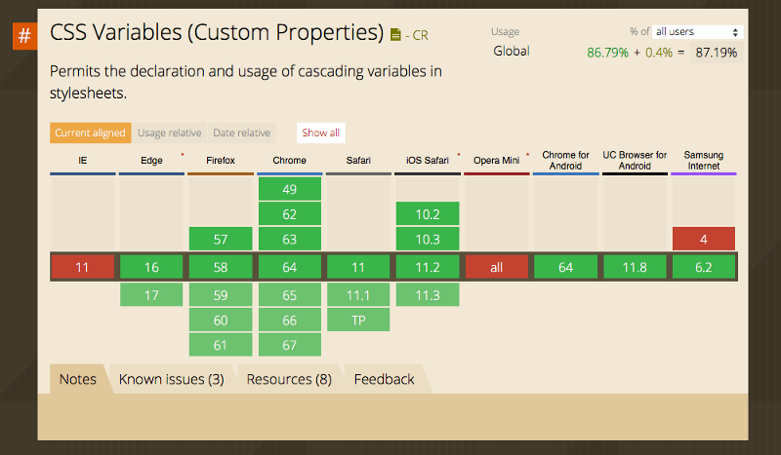[caniuse](https://caniuse.com/#search=css%20var)

So, can you use CSS variables in production today? I’ll say yes! Be sure to check what the adoption rate is for yourself, though.

On the bright side, you can use a preprocessor like [Myth](http://www.myth.io). It’ll preprocess your ‘future’ CSS into something you use today. How cool, huh?

If you have some experience using [postCSS](http://postcss.org), that’s equally a great way to use future CSS today. Here’s a [postCSS module for CSS variables](https://www.npmjs.com/package/postcss-css-variables).